Instruction:

Complete all questions in 2:30 hrs

Let’s get started with some helpful Batch scripts:

1. What is Windows Start-up? How can all the start-up programs be viewed?

Ans: Startup is the process of getting the computer, operating system, equipment, or software ready to use. The boot or boot up are other typical names for this action.

1. Write a batch script to display a simple “Hello YourName” message during the startup.

**Note: Copy the file to the Startup folder**

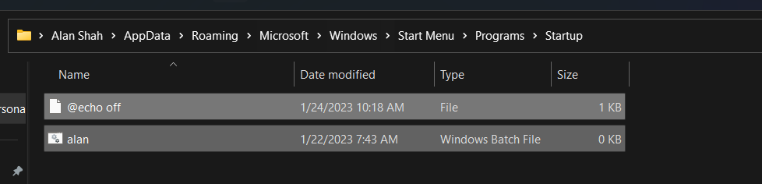

1. Write a batch script to schedule to automatically back up important files and folders to a different location at a scheduled time.

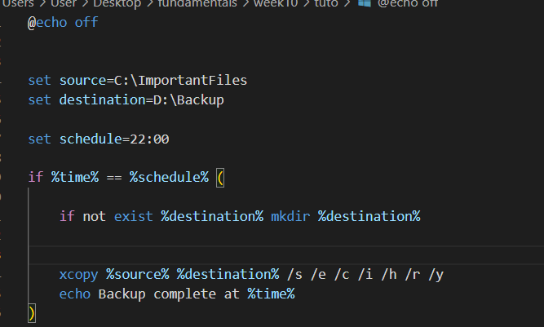

1. Write a Windows batch script that automatically deletes temporary files and clears out the recycle bin to free up space on the hard drive.

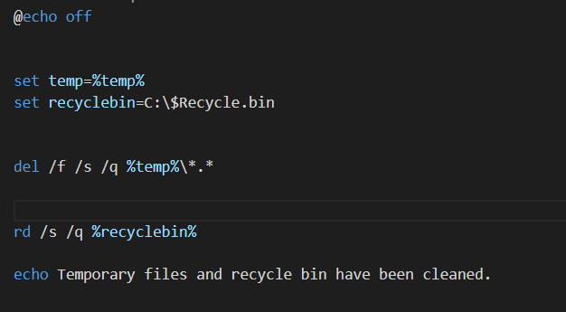

1. Write a windows batch script that can be run to diagnose and troubleshoot common network issues

1. Write a batch script that can be scheduled to shut down the computer at a specific time(**using** **WINDOWS TASK SCHEDULER**).

1. Copy the following script Save this and run this in the **Downloads** directory or any directory you want.

*@echo off*

*for %%a in (".\*") do (*

*if "%%~xa" NEQ "" if "%%~dpxa" NEQ "%~dpx0" (*

*if not exist "%%~xa" mkdir "%%~xa" (*

*move "%%a" "%%~dpa%%~xa\"*

*)*

*)*

*)*

What does the above script do? Elaborate on your answer.

The purpose of this script is to arrange the files in a certain directory by dividing them into subdirectories depending on their file extensions. Before entering a loop that iterates over all of the files and directories in the current directory, the script first disables the console's display of commands. The script verifies that the currently selected item is not a file and is not located in the same directory as the script file. When these criteria are satisfied, the script, if necessary, creates a new directory with the same name as the file extension if one doesn't already exist. In order to organize the files in the current directory by placing all files with the same extension in one directory, the script utilizes the move command to relocate the current file to the newly formed directory.